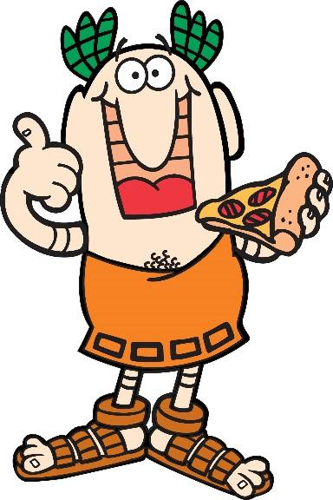

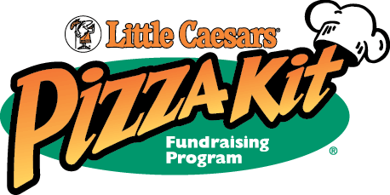

_______________________________________________________________

We’re raising money for Yearbook Club
It’s time for you, your friends, and your family to stock up with Little Caesars Pizza Kits! Have them on hand for quick dinners, parties or entertaining! We are asking that everyone sell 10 kits to help us reach our goal.

How: Fill out the top portion of your order form with your name and the best contact phone number (cell phones preferred). Collect payment at the time you take orders. We can take cash or checks made payable to:

Schroon Lake Central School

You may also order and pay online by credit or debit card:
- Go to www.PizzaKit.com
- Click on -“Products” then “Shop”
- Select either- “Ship Order to the Group” or “Ship Order to Me”(via UPS for an additional fee)

Our Fundraiser ID # is 384950

When: Fundraiser start date: Monday, April 12, 2021

Order form and payment due: Friday, April 30, 2021
Please make checks payable to: SLCS Yearbook

Time and Date of Pizza Kit Pickup: Week of May 17th TBD

Where: Pickup will be at: SLCS Room 220
Please pick up your pizza kits as soon as possible as we do not have onsite storage.
We are not responsible for orders that are not picked up on delivery day.

Volunteers Needed: We’ll also need several helpers on the day of delivery to help sort orders.
Please call or email for details.

Chairperson: Laura Corey Phone: 532-7164 Ext. 3391

Email Address: lcorey@slwildcats.com
Thank you for your support and participation! Have fun!

